# Chapter 5 – Probability

## OUTLINE

1. Probability Rules
2. The Addition Rule and Complements
3. Independence and the Multiplication Rule
4. Conditional Probability and the General Multiplication Rule
5. Counting Techniques
6. Simulation
7. Putting It Together: Which Method Do I Use?

## Putting It Together

In Chapter 1, we learned the methods of collecting data. In Chapters 2 through 4, we learned how to summarize raw data using tables, graphs, and numbers. As far as the statistical process goes, we have discussed the collecting, organizing, and summarizing parts of the process.

Before we begin to analyze data, we introduce probability, which forms the basis of inferential statistics. Why? Well, we can think of the probability of an outcome as the likelihood of observing that outcome. If something has a high likelihood of happening, it has a high probability (close to 1). If something has a small chance of happening, it has a low probability (close to 0). For example, it is unlikely that we would roll five straight sixes when rolling a single die, so this result has a low probability. In fact, the probability of rolling five straight sixes is 0.0001286. If we were playing a game in which a player threw five sixes in a row with a single die, we would consider the player to be lucky (or a cheater) because it is such an unusual occurrence. Statisticians use probability in the same way. If something occurs that has a low probability, we investigate to find out “what’s up.”

## Section 5.1 Probability Rules

### Objectives

1. Understand Random Processes and the Law of Large Numbers
2. Apply the Rules of Probabilities
3. Compute and Interpret Probabilities Using the Empirical Method
4. Compute and Interpret Probabilities Using the Classical Method
5. Recognize and Interpret Subjective Probabilities

#### Objective 1: Understand Random Processes and the Law of Large Numbers

Objective 1, Page 1

 *Answer the following while watching the video.*

1. Define simulation.
2. Define a random process.

The **short run** is a few repetitions of the simulation, while the **long run** is many repetitions of the simulation. In this video, there is a lot of variability in the proportion of heads observed in the short run, while in the long run the proportion of heads approaches 0.5.

Objective 1, Page 6

1. Define probability.
2. State the Law of Large Numbers.

Objective 1, Page 7

 *Answer the following after finishing Activity 1: The Law of Large Numbers.*

1. After rolling the die 1000 times, is the behavior in the short run (fewer rolls of the die) the same as it was with the first 1000 runs? Based on your results, what is the probability of rolling a 4 with a 10-sided die?

Objective 1, Page 9

 *Answer the following after watching the video.*

1. Explain the meaning of the sentence, “In a random process, the trials are memoryless.”
2. For a family whose first four children are girls, is the family more likely on the fifth child to have a boy?

Objective 1, Page 11

1. In probability, what is an experiment?

Objective 1, Page 13

**Example 1 *Identifying Events and the Sample Space of a Probability Experiment***

A probability experiment consists of rolling a single six-sided fair die. A fair die is one in which each possible outcome is equally likely. For example, rolling a two is just as likely as rolling a five.

1. Identify the outcomes of the probability experiment.
2. Define the sample space.
3. Define the event E = “roll an even number.”

#### Objective 2: Apply the Rules of Probabilities

Objective 2, Page 1

1. State Rules 1 and 2 of the rules of probabilities.
2. What is a probability model?

Objective 2, Page 2

**Example 2 *A Probability Model***

In a bag of peanut M&M milk chocolate candies, the colors of the candies can be brown, yellow, red, blue, orange, or green. Suppose that a candy is randomly selected from a bag. The table shows each color and the probability of drawing that color. Verify this is a probability model.

| **Color** | **Probability** |
| --- | --- |
| Brown | 0.12 |
| Yellow | 0.15 |
| Red | 0.12 |
| Blue | 0.23 |
| Orange | 0.23 |
| Green | 0.15 |

Objective 2, Page 4

* If an event is impossible, the probability of the event is 0.
* If an event is a certainty, the probability of the event is 1.
* The closer a probability is to 1, the more likely the event will occur.
* The closer a probability is to 0, the less likely the event will occur.
* For example, an event with probability 0.8 is more likely to occur than an event with probability 0.75.
* An event with probability 0.8 will occur about 80 times out of 100 repetitions of the experiment, whereas an event with probability 0.75 will occur about 75 times out of 100.

Objective 2, Page 6

1. What is an unusual event? What cutoff points do statisticians typically use for identifying unusual events?

Objective 2, Page 8

1. List the three methods in this section for determining the probability of an event.

#### Objective 3: Compute and Interpret Probabilities Using the Empirical Method

Objective 3, Page 1

1. Explain how to approximate probabilities using the empirical approach.

Objective 3, Page 2

**Example 3 *Using Relative Frequencies to Approximate Probabilities***

An insurance agent currently insures 182 teenage drivers (ages 16 to 19). Last year, 24 of the teenagers had to file a claim on their auto policy. Based on these results, the probability that a teenager will file a claim on his or her auto policy in a given year is

Objective 3, Page 4

**Example 4 *Building a Probability Model from a Random Process***

Pass the PigsTM is a Milton-Bradley game in which pigs are used as dice. Points are earned based on the way the pig lands. There are six possible outcomes when one pig is tossed. A class of 52 students rolled pigs 3939 times. The number of times each outcome occurred is recorded in the table.

(*Source:* [www.members.tripod.com/~passpigs/prob.html](http://www.members.tripod.com/~passpigs/prob.html))

| **Outcome** | **Frequency** |
| --- | --- |
| Side with no dot | 1344 |
| Side with dot | 1294 |
| Razorback | 767 |
| Trotter | 365 |
| Snouter | 137 |
| Leaning Jowler | 32 |

1. Use the results of the experiment to build a probability model for the way the pig lands.
2. Estimate the probability that a thrown pig lands on the “side with the dot”.
3. Would it be unusual to throw a “Leaning Jowler”?

Objective 3, Page 5

Surveys are probability experiments. Why? Each time a survey is conducted, a different random sample of individuals is selected. Therefore, the results of a survey are likely to be different each time the survey is conducted because different people are included.

#### Objective 4: Compute and Interpret Probabilities Using the Classical Method

Objective 4, Page 1

1. What requirement must be met in order to compute probabilities using the classical method?

Objective 4, Page 1(Continued)

1. Explain how to compute probabilities using the classical method.

Objective 4, Page 2

**Example 5 *Computing Probabilities Using the Classical Approach***

A pair of fair dice is rolled. Fair die are die where each outcome is equally likely. The possible outcomes of this experiment are shown in Figure 1.

**Figure 1**

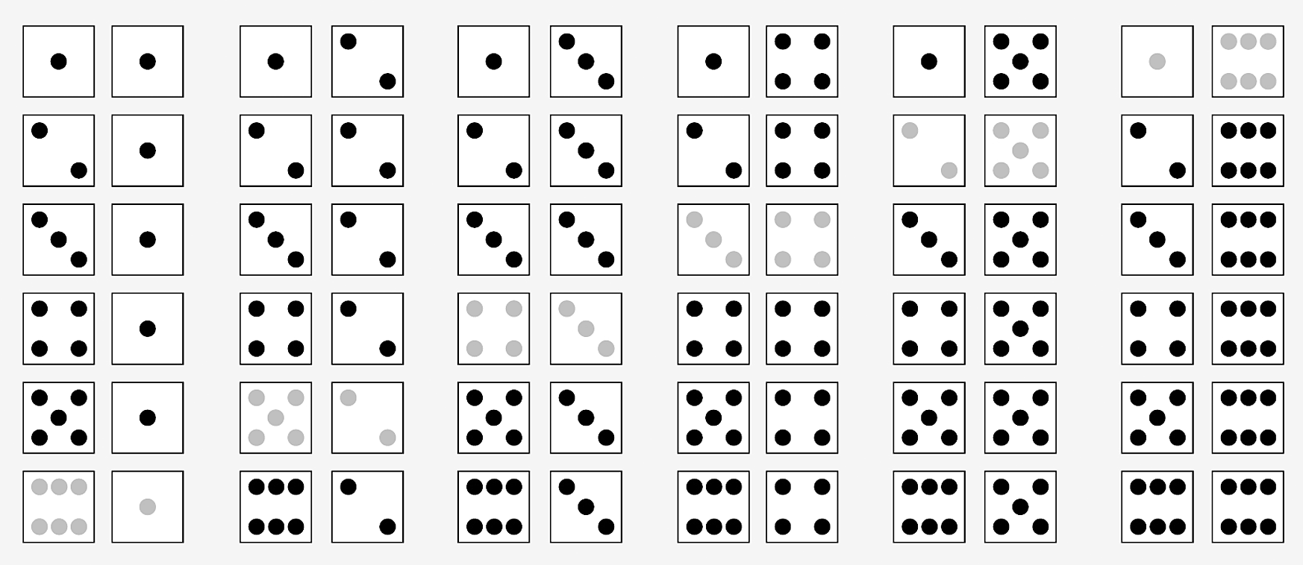

1. Compute the probability of rolling a seven.
2. Compute the probability of rolling "snake eyes"; that is, compute the probability of rolling a two.
3. Comment on the likelihood of rolling a seven versus rolling a two.

Objective 4, Page 4

1. As the number of trials of an experiment increase, how does the empirical probability of an event occurring compare to the classical probability of that event occurring?

Objective 4, Page 5

**Example 6 *Computing Probabilities Using Equally Likely Outcomes***

Sophia has three tickets to a concert, but Yolanda, Michael, Kevin, and Marissa all want to go to the concert with her. To be fair, Sophia wants to randomly select the two people who will go with her.

1. Determine the sample space of the experiment. In other words, list all possible simple random samples of size *n* = 2.
2. Compute the probability of the event "Michael and Kevin attend the concert."
3. Compute and interpret the probability of the event "Marissa attends the concert."

Objective 4, Page 7

**Example 7 *Comparing the Classical Method and Empirical Method***

Suppose that a survey asked 500 families with three children to disclose the gender of their children and found that 180 of the families had two boys and one girl.

1. Estimate the probability of having two boys and one girl in a three-child family, using the empirical method.
2. Compute and interpret the probability of having two boys and one girl in a three-child family, using the classical method and assuming boys and girls are equally likely.

Objective 4, Page 8

Empirical probabilities and classical probabilities often differ in value, but as the number of repetitions of a probability experiment increases, the empirical probability should get closer to the classical probability according to the Law of Large Numbers.

#### Objective 5: Recognize and Interpret Subjective Probabilities

Objective 5, Page 1

1. What is a subjective probability? Explain why subjective probabilities are used.

## Section 5.2 The Addition Rule and Complements

### Objectives

1. Use the Addition Rule for Disjoint Events
2. Use the General Addition Rule
3. Compute the Probability of an Event Using the Complement Rule

#### Objective 1: Use the Addition Rule for Disjoint Events

Objective 1, Page 1

 *Answer the following as you watch the video.*

1. What does it mean for two events to be disjoint?
2. In a Venn diagram, what does the rectangle represent? What does a circle represent?
3. How can you tell from a Venn diagram that two events are not disjoint?
4. For disjoint events *E* and *F*, how is *P*(*E* or *F*) related to *P*(*E*) and *P*(*E*)?
5. State the Addition Rule for Disjoint Events.

Objective 1, Page 3

**Example 1 *Benford’s Law and the Addition Rule for Disjoint Events***

Our number system consists of the digits 0, 1, 2, 3, 4, 5, 6, 7, 8, and 9. Because we do not write numbers such as 12 as 012, the first significant digit in any number must be 1, 2, 3, 4, 5, 6, 7, 8, or 9. Although we may think that each digit appears with equal frequency so that each digit has a  probability of being the first significant digit, this is not true. In 1881, Simon Newcomb discovered that first-digits do not occur with equal frequency. The physicist Frank Benford discovered the same result in 1938. After studying a great deal of data, he assigned probabilities of occurrence for each of the first digits, as shown in Table 2. The probability model is now known as Benford's Law and plays a major role in identifying fraudulent data on tax returns and accounting books.

**Table 2**

| Digit | 1 | 2 | 3 | 4 | 5 | 6 | 7 | 8 | 9 |
| --- | --- | --- | --- | --- | --- | --- | --- | --- | --- |
| Probability | 0.301 | 0.176 | 0.125 | 0.097 | 0.079 | 0.067 | 0.058 | 0.051 | 0.046 |

Data from The First Digit Phenomenon, T. P. Hill, American Scientist, July–August, 1998

1. Verify that Benford's Law is a probability model.
2. Use Benford's Law to determine the probability that a randomly selected first digit is 1 or 2.
3. Use Benford's Law to determine the probability that a randomly selected first digit is at least 6.

Objective 1, Page 4

**Example 2 *A Deck of Cards and the Addition Rule for Disjoint Events***

Suppose that a single card is selected from a standard 52-card deck, such as the one shown in Figure 3.

**Figure 3**

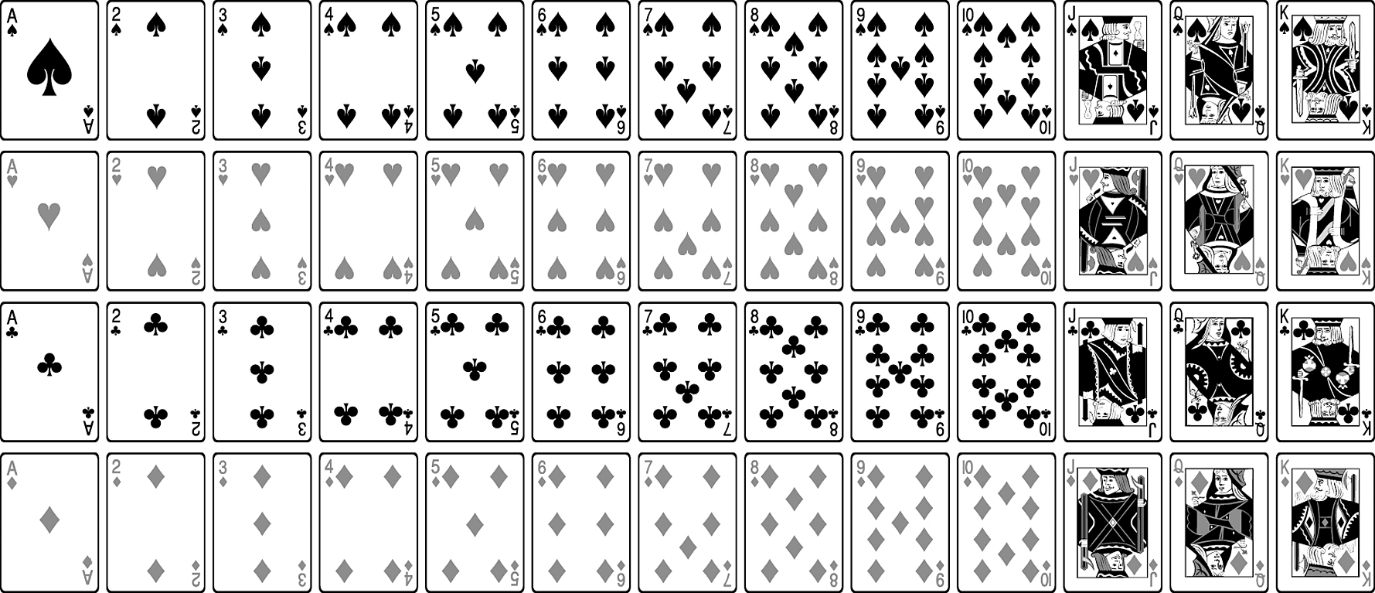

1. Compute the probability of the event *E* = “drawing a king.”
2. Compute the probability of the event *E* = “drawing a king” or *F* = “drawing a queen” or *G* = “drawing a jack.”

#### Objective 2: Use the General Addition Rule

Objective 2, Page 1

1. State the General Addition Rule.
2. Explain why we subtract *P*(*E* and *F*) when using the General Addition Rule.

Objective 2, Page 3

**Example 3 *Computing Probabilities for Events That Are Not Disjoint***

Suppose a single card is selected from a standard 52-card deck. Compute the probability of the event *E* = “drawing a king” or *F* = “drawing a diamond.”

Objective 2, Page 5

A table that relates two categories of data is called a **contingency table** (or **two-way table**).

The **row variable** is the variable that describes each row in the contingency table.

The **column variable** is the variable that describes each column in the contingency table.

Objective 2, Page 6

**Example 4 *Using the Addition Rule with Contingency Tables***

Use the data in Table 3 to answer parts (A) through (D).

**Table 3**

|  | **Gender** | **Gender** |
| --- | --- | --- |
| **Marital Status** | **Males (in millions)** | **Females (in millions)** |
| **Never married** | 44.1 | 39 |
| **Married** | 66.7 | 67.5 |
| **Widowed** | 3.5 | 11.4 |
| **Divorced** | 10.7 | 14.8 |

Data from U.S. Census Bureau, Current Population Reports

1. Determine the probability that a randomly selected U.S. resident 15 years and older is male.
2. Determine the probability that a randomly selected U.S. resident 15 years and older is widowed.
3. Determine the probability that a randomly selected U.S. resident 15 years and older is widowed or divorced.
4. Determine the probability that a randomly selected U.S. resident 15 years and older is male or widowed.

#### Objective 3: Compute the Probability of an Event Using the Complement Rule

Objective 3, Page 1

1. Define the complement of an event *E*.
2. State the Complement Rule.

Objective 3, Page 2

**Example 5 *Illustrating the Complement Rule***

According to the American Veterinary Medical Association, 31.6% of American households own a dog. What is the probability that a randomly selected household does not own a dog?

Objective 3, Page 4

**Example 6 *Computing Probabilities Using Complements***

The data in Table 4 represent the travel time to work for residents of Hartford County, Connecticut.

**Table 4**

| **Travel Time** | **Frequency** |
| --- | --- |
| Less than 5 minutes | 24,358 |
| 5 to 9 minutes | 39,112 |
| 10 to 14 minutes | 62,124 |
| 15 to 19 minutes | 72,854 |
| 20 to 24 minutes | 74,386 |
| 25 to 29 minutes | 30,099 |
| 30 to 34 minutes | 45,043 |
| 35 to 39 minutes | 11,169 |
| 40 to 44 minutes | 8045 |
| 45 to 59 minutes | 15,650 |
| 60 to 89 minutes | 5451 |
| 90 or more minutes | 4895 |

Data from United States Census Bureau

1. What is the probability that a randomly selected resident has a travel time of 90 or more minutes?
2. What is the probability that a randomly selected resident of Hartford County, Connecticut will have a travel time less than 90 minutes?

## Section 5.3 Independence and the Multiplication Rule

### Objectives

1. Identify Independent Events
2. Use the Multiplication Rule for Independent Events
3. Compute At-least Probabilities

#### Objective 1: Identify Independent Events

Objective 1, Page 1

 *Answer the following as you watch the video.*

1. Define independent events and dependent events.
2. Explain why the events “draw a heart” and “roll an even number” are independent.
3. Explain why the events “woman 1 survives the year” and “woman 2 survives the year” are dependent if the two women live in the same complex.
4. When we take a very small sample from a very large finite population, we make the assumption of independence even though the events are technically dependent. State the general rule of thumb for assuming independence.

Objective 1, Page 4

1. Are disjoint events independent?

#### Objective 2: Use the Multiplication Rule for Independent Events

Objective 2, Page 1

1. State the Multiplication Rule for Independent Events.

Objective 2, Page 2

**Example 1 *Computing Probabilities of Independent Events***

In the game of roulette, the wheel has slots numbered 0, 00, and 1 through 36. A metal ball rolls around a wheel until it falls into one of the numbered slots. What is the probability that the ball will land in the slot numbered 17 two times in a row?

Objective 2, Page 3

1. State the Multiplication Rule for *n* Independent Events.

Objective 2, Page 4

**Example 2 *Life Expectancy***

The probability that a randomly selected 24-year-old male will survive the year is 0.9986 according to the National Vital Statistics Report, Vol. 56, No. 9.

1. What is the probability that three randomly selected 24-year-old males will survive the year?
2. What is the probability that twenty randomly selected 24-year-old males will survive the year?

#### Objective 3: Compute At-least Probabilities

Objective 3, Page 1

Usually, when computing probabilities involving the phrase *at least*, use the Complement Rule.

The phrase *at least* means “greater than or equal to.”

Objective 3, Page 2

**Example 3 *Computing At-least Probabilities***

The probability that a randomly selected female aged 60 years will survive the year is 0.99186 according to the National Vital Statistics Report. What is the probability that at least one of 500 randomly selected 60-year-old females will die during the course of the year?

Objective 3, Page 4

### Summary: Rules of Probability

**Rule 1** The probability of any event must be between 0 and 1, inclusive. If we let *E* denote any event, then .

**Rule 2** The sum of the probabilities of all outcomes in the sample space must equal 1. That is, if the sample space , then



**Rule 3** If *E* and *F* are disjoint events, then *P(E or F) = P(E) + P(F).* If *E* and *F* are not disjoint events, then .

**Rule 4** If *E* represents any event and  represents the complement of *E*, then .

**Rule 5** If *E* and *F* are independent events, then

**

Notice that *or* probabilities use the Addition Rule, whereas *and* probabilities use the Multiplication Rule. Accordingly, *or* probabilities imply addition, whereas *and* probabilities imply multiplication.

## Section 5.4 Conditional Probability and the General Multiplication Rule

### Objectives

1. Compute Conditional Probabilities
2. Compute Probabilities Using the General Multiplication Rule

#### Objective 1: Compute Conditional Probabilities

Objective 1, Page 1

1. What does the notation  represent?

Objective 1, Page 3

**Example 1 *An Introduction to Conditional Probability***

Suppose a single die is rolled. What is the probability that the die comes up three? Now suppose that the die is rolled a second time, but we are told the outcome will be an odd number. What is the probability that the die comes up three?

Objective 1, Page 5

1. State the Conditional Probability Rule.

Objective 1, Page 6

**Example 2 *Conditional Probabilities on Marital Status and Gender***

The data in Table 5 represent the marital status and gender of U.S. residents aged 15 years and older in 2016.

**Table 5**

|  | Males (in millions) | Females (in millions) | Totals (in millions) |
| --- | --- | --- | --- |
| Never Married | 44.1 | 39.0 | 83.1 |
| Married | 66.7 | 67.5 | 134.2 |
| Widowed | 3.5 | 11.4 | 14.9 |
| Divorced | 10.7 | 14.8 | 25.5 |
| Totals (in millions) | 125.0 | 132.7 | 257.7 |

1. Compute the probability that a randomly selected individual never married, given that the individual is male.
2. Compute the probability that a randomly selected individual is male, given that the individual never married.

Objective 1, Page 8

**Example 3 *Birth Weights of Preterm Babies***

Suppose that 12.2% of all births are preterm. (Preterm means that the gestation period of the pregnancy is less than 37 weeks.) Also, 0.2% of all births result in a preterm baby who weighs 8 pounds, 13 ounces or more. What is the probability that a randomly selected baby weighs 8 pounds, 13 ounces or more, given that the baby is preterm? Is this unusual? Data based on the Vital Statistics Reports.

#### Objective 2: Compute Probabilities Using the General Multiplication Rule

Objective 2, Page 1

1. State the General Multiplication Rule.

Objective 2, Page 2

**Example 4 *Using the General Multiplication Rule***

The probability that a driver who is speeding gets pulled over is 0.8. The probability that a driver gets a ticket, given that he or she is pulled over, is 0.9. What is the probability that a randomly selected driver who is speeding gets pulled over and gets a ticket?

Objective 2, Page 4

**Example 5 *Acceptance Sampling***

Suppose that of 100 circuits sent to a manufacturing plant, 5 are defective. The plant manager receiving the circuits randomly selects two and tests them. If both circuits work, she will accept the shipment. Otherwise, the shipment is rejected. What is the probability that the plant manager discovers at least one defective circuit and rejects the shipment?

Objective 2, Page 6

**Example 6 *Favorite Other***

In a study to determine whether preferences for self are more or less prevalent than preferences for others, researchers first asked individuals to identify the person who is most valuable and likeable to you, or favorite other.

Of the 1519 individuals surveyed, 42 had chosen themselves as their favorite other.

Source: Gebauer JE, et al. Self-Love or Other-Love? Explicit Other-Preference but Implicit Self-Preference. PLoS ONE 7(7):e41789. doi:10.1371/journal.prone.0041789

1. Suppose we randomly select 1 of the 1519 individuals surveyed. What is the probability that he or she chose themselves as their favorite other?
2. If two individuals from this group are randomly selected, what is the probability that both chose themselves as their favorite other?
3. Compute the probability of randomly selecting two individuals from this group who selected themselves as their favorite other assuming independence.

Objective 2, Page 7

If small random samples are taken from large populations without replacement, it is reasonable to assume independence of the events. As a rule of thumb, if the sample size, *n*, is less than 5% of the population size, *N*, we treat the events as independent. That is, if *n* < 0.05*N*, treat the events as independent.

Objective 2, Page 9

1. State the definition for independence using conditional probabilities.

## Section 5.5 Counting Techniques

### Objectives

1. Solve Counting Problems Using the Multiplication Rule
2. Solve Counting Problems Using Permutations
3. Solve Counting Problems Using Combinations
4. Solve Counting Problems Involving Permutations with Nondistinct Items
5. Compute Probabilities Involving Permutations and Combinations

#### Objective 1: Solve Counting Problems Using the Multiplication Rule

Objective 1, Page 2

**Example 1 *Counting the Number of Possible Meals***

The fixed-price dinner at Mabenka Restaurant provides the following choices:

Appetizer: soup or salad

Entrée: baked chicken, broiled beef patty, baby beef liver, or roast beef au jus

Dessert: ice cream or cheesecake

How many different meals can be ordered?

Objective 1, Page 3

1. State the Multiplication Rule of Counting.

Objective 1, Page 4

**Example 2 *Counting Airport Codes (Repetition Allowed)***

The International Airline Transportation Association (IATA) assigns three-letter codes to represent airport locations. For example, the code for Fort Lauderdale International Airport is FLL. How many different airport codes are possible?

Objective 1, Page 5

**Example 3 *Counting (Without Repetition)***

Three members from a 14-member committee are to be randomly selected to serve as chair, vice-chair, and secretary. The first person selected is the chair, the second is the vice-chair, and the third is the secretary. How many different committee structures are possible?

Objective 1, Page 7

1. Give the definition of *n* factorial.

Objective 1, Page 10

**Example 4 *The Traveling Salesperson***

You have just been hired as a book representative for Pearson Education.

On your first day, you must travel to seven schools to introduce yourself.

How many different routes are possible?

#### Objective 2: Solve Counting Problems Using Permutations

Objective 2, Page 1

1. State the definition of a permutation.

Objective 2, Page 2

1. State the formula for the number of permutations of *n* distinct objects taken *r* at a time.

Objective 2, Page 3

**Example 5 *Computing Permutations***

Evaluate:

1. 
2. 

Objective 2, Page 5

**Example 6 *Betting the Trifecta***

In how many ways can horses in a ten-horse race finish first, second, and third?

#### Objective 3: Solve Counting Problems Using Combinations

Objective 3, Page 1

1. State the definition of a combination.

Objective 3, Page 2

**Example 7 *Listing* Combinations**

Roger, Ken, Tom, and Jay are going to play golf. They will randomly select teams of two players each. List all possible team combinations. That is, list all the combinations of the four people Roger, Ken, Tom, and Jay taken two at a time. What is ?

Objective 3, Page 4

1. State the formula for the number of combinations of *n* distinct objects taken *r* at a time.

Objective 3, Page 5

**Example 8 *Computing Combinations***

Evaluate:

1. 
2. 
3. 

Objective 3, Page 7

**Example 9 *Simple Random Samples***

How many different simple random samples of size 4 can be obtained from a population whose size is 20?

#### Objective 4: Solve Counting Problems Involving Permutations with Nondistinct Items

Objective 4, Page 1

**Example 10 *DNA Sequence***

A DNA sequence consists of a series of letters representing a DNA strand that spells out the genetic code. There are four possible letters (A, C, G, and T), each representing a specific nucleotide base in the DNA strand (adenine, cytosine, guanine, and thymine, respectively).

How many distinguishable sequences can be formed using two As, two Cs, three Gs, and one T?

Objective 4, Page 2

1. State the formula for permutations with nondistinct items.

Objective 4, Page 3

**Example 11 *Arranging Flags***

How many different vertical arrangements are there of ten flags if five are white, three are blue, and two are red?

Objective 4, Page 5

**Summary: Combinations and Permutations**

|  | **Description** | **Formula** |
| --- | --- | --- |
| **Combination** | The selection of *r* objects from a set of *n* different objects when the order in which the objects are selected does not matter (so *AB* is the same as *BA*) and an object cannot be selected more than once (repetition is not allowed) |  |
| **Permutation of Distinct Items with Replacement** | The selection of *r* objects from a set of *n* different objects when the order in which the objects are selected matters (so *AB* is different from *BA*) and an object may be selected more than once (repetition is allowed) |  |
| **Permutation of Distinct Items without Replacement** | The selection of *r* objects from a set of *n* different objects when the order in which the objects are selected matters so (*AB* is different from *BA*) and an object cannot be selected more than once (repetition is not allowed) |  |
| **Permutation of Nondistinct Items without Replacement** | The number of ways *n* objects can be arranged (order matters) in which there are  of one kind, of a second kind, …, and  of a *k*th kind, where |  |

#### Objective 5: Compute Probabilities Involving Permutations and Combinations

Objective 5, Page 2

**Example 12 *Winning the Lottery***

In the Illinois Lottery, an urn contains balls numbered 1 to 52. From this urn, six balls are randomly chosen without replacement. For a $1 bet, a player chooses two sets of six numbers. To win, all six numbers must match those chosen from the urn. The order in which the balls are picked does not matter. What is the probability of winning the lottery?

Objective 5, Page 3

**Example 13 *Acceptance Sampling***

A shipment of 120 fasteners that contains 4 defective fasteners was sent to a manufacturing plant. The plant's quality control manager randomly selects and inspects 5 fasteners. What is the probability that exactly 1 of the inspected fasteners is defective?

## Section 5.6 Simulation

### Objective

1. Use Simulation to Obtain Probabilities

#### Objective 1: Use Simulation to Obtain Probabilities

Objective 1, Page 1

 *Answer the following while watching the video.*

1. List two historical uses of simulation.

Objective 1, Page 2

**Example 1 *Getting Out of Jail in Monopoly***

In the board game Monopoly, a player can get out of jail in one of three ways.

1. The player pays a $50 fine.
2. The player uses a “Get Out of Jail” card.
3. The player rolls doubles.

If the player does not roll doubles after three rolls, the player must pay the $50 fine. Use simulation to determine the probability that a player will not roll doubles after three consecutive rolls.

Objective 1, Page 5

When collecting data for an observational study, it is important that individuals are randomly selected to be in the study. This allows the results of the study to be extended to the population from which the individuals were randomly selected.

When collecting data for a designed experiment, it is important that the individuals are randomly assigned to the various treatment groups in the study. This allows us to make statements of causation between the levels of treatment and the response variable in the study.

Objective 1, Page 6

**Example 2 *Random Selection–Qualitative Response***

Unplugging refers to eliminating the use of social media, cell phones, and other technology. According to Harris Interactive, the proportion of adult Americans (aged 18 years or older) who attempt to “unplug” at least once a week is 0.45. There are approximately 241,000,000 Americans aged 18 years or older in the United States.

1. Simulate obtaining a simple random sample of size 500 from the population. How many of the individuals sampled unplug? How many do not unplug? What proportion unplug at least once a week?
2. Simulate obtaining a second simple random sample of size 500 from the population. How many of the individuals sampled unplug? How many do not unplug? What proportion unplug at least once a week? Why will the results of the first sample differ from those in the second sample?
3. Now simulate obtaining at least 2000 more simple random samples of size 500 from the population. Based on the simulation, what is the probability of obtaining a random sample where the proportion who unplug at least once a week is greater than 0.50? Would it be unusual to obtain a sample proportion greater than 0.5 from this population? Explain.

## Section 5.7 Putting It Together: Which Method Do I Use?

### Objectives

1. Determine the Appropriate Probability Rule to Use
2. Determine the Appropriate Counting Technique to Use

#### Objective 1: Determine the Appropriate Probability Rule to Use

Objective 1, Page 1

**Flowchart for Probability Rules**

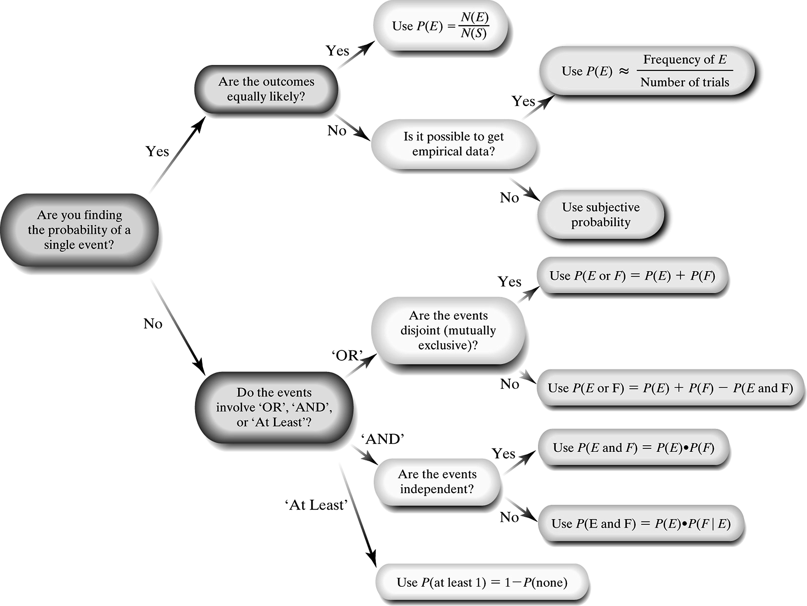

1. What are three options when finding the probability of a single event?

OBJECTIVE 1, PAGE 1 (CONTINUED)

1. What must you determine when working with events involving the word “AND”?
2. What must you determine when working with events involving the word “OR”?

Objective 1, Page 2

**Example 1 *Probability: Which Rule Do I Use?***

In the game show Deal or No Deal?, a contestant is presented with 26 suitcases that contain amounts ranging from $0.01 to $1,000,000. The contestant must pick an initial case that is set aside as the game progresses. The amounts are randomly distributed among the suitcases prior to the game as shown in Table 7. What is the probability that the contestant picks a case worth at least $100,000?

**Table 7**

| **Prize** | **Number of Suitcases** |
| --- | --- |
| $0.01–$100 | 8 |
| $200–$1000 | 6 |
| $5000–$50,000 | 5 |
| $100,000–$1,000,000 | 7 |

Objective 1, Page 3

**Example 2 *Probability: Which Rule Do I Use?***

According to a Harris poll, 14% of adult Americans have one or more tattoos, 50% have pierced ears, and 65% of those with one or more tattoos also have pierced ears. What is the probability that a randomly selected adult American has one or more tattoos and pierced ears?

#### Objective 2: Determine the Appropriate Counting Technique to Use

Objective 2, Page 1

**Flowchart for Counting Techniques**

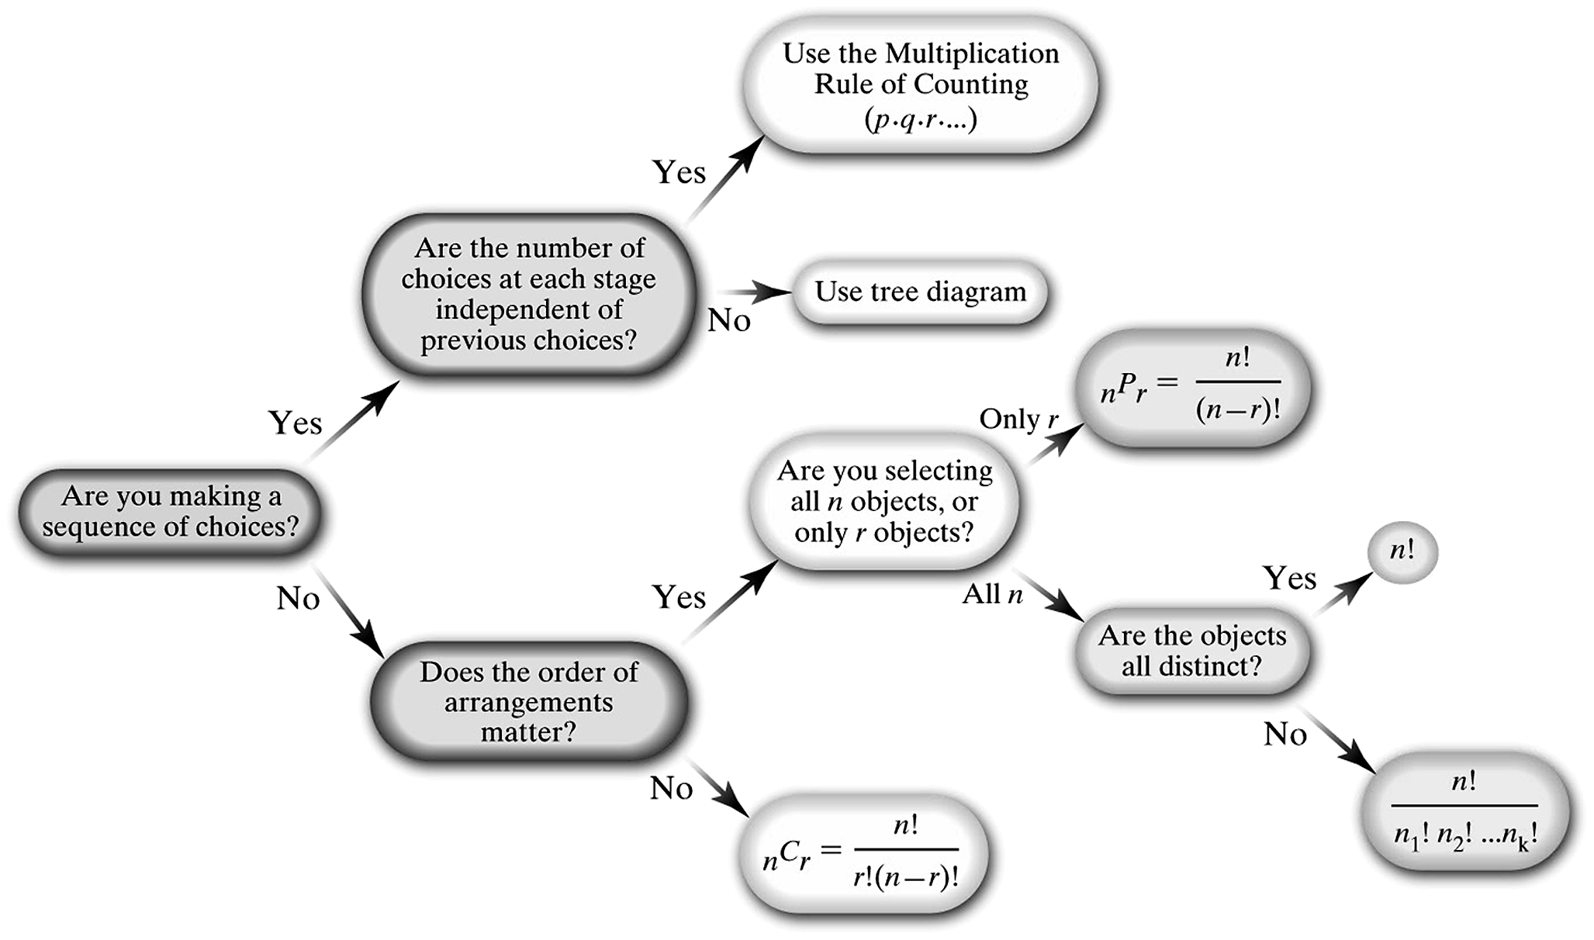

1. What counting techniques can be used when working with a sequence of choices? Explain when to use each strategy.
2. What counting techniques can be used when working with the number of arrangements of items? Explain when to use each strategy.

Objective 2, Page 2

**Example 3 *Counting: Which Technique Do I Use?***

The Hazelwood city council consists of 5 men and 4 women. How many different subcommittees can be formed that consist of 3 men and 2 women?

Objective 2, Page 3

**Example 4 *Counting: Which Technique Do I Use?***

The Daytona 500, the season opening NASCAR event, has 43 drivers in the race. In how many different ways could the top four finishers (first, second, third, and fourth place) occur?